Task 1

import java.util.ArrayList**;**import java.util.Arrays**;**import java.util.List**;**public class Main {  
 public static void main(String[] args) {  
 System.*out*.println("Hello world!")**;** ArrayList<String> List = new ArrayList<String>()**;** List.add("10")**;** List.add("15.3")**;** List.add("5")**;** List.add("xyz")**;** int sum = **0;** int count = **0;** for (String input : List) {  
 try {  
 if (List.isEmpty())  
 throw new NullPointerException("List is Empty")**;** int num = Integer.*parseInt*(input)**;** sum += num**;** count++**;** } catch (NumberFormatException e) {  
 System.*out*.println("invalid input: " + input)**;** }  
 catch (NullPointerException ne){  
 System.*out*.println(ne.getMessage())**;** }  
 }  
 if (count > **0**) {  
 double average = (double) sum / count**;** System.*out*.println("Average is: " + average)**;** } else {  
 System.*out*.println("No valid integers found in input list.")**;** }  
 }  
}

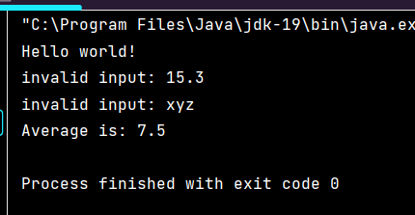

Task 2

import java.util.Scanner**;**public class Main {  
 public static void main(String[] args) {  
 System.*out*.println("Hello world!")**;** Scanner get = new Scanner(System.*in*)**;** System.*out*.println("Input Number")**;** String input = get.next()**;** try {  
 if (input == null || input.isEmpty()) {  
 throw new IllegalArgumentException("Error: Input string cannot be null or empty.")**;** }  
 int ip= Integer.*parseInt*(input)**;** if (ip < **0**) {  
  
 throw new IllegalArgumentException("Error: Input integer must be positive.")**;**}  
 else {  
 long factorial=**1;** do{  
 factorial=factorial*ip--**;** }while (ip!=**1**)**;** System.*out*.println("Factorial is "+factorial)**;**}  
 }catch (IllegalArgumentException e){  
 System.*out*.println(e.getMessage())**;** }  
 catch (ArithmeticException ex){  
 System.*out*.println(ex.getMessage())**;** }  
 }  
}

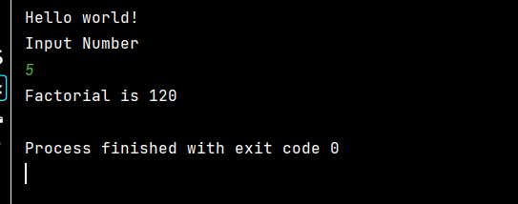

Task 3

import java.util.Scanner**;**public class Main {  
 public static void main(String[] args) {  
 System.*out*.println("Hello world!")**;** Scanner get = new Scanner(System.*in*)**;** Integer a = get.nextInt()**;** Integer b = get.nextInt()**;** try {  
 if (a==null||b==null){  
 throw new IllegalArgumentException("Input can not be Empty")**;** }  
 System.*out*.print("Enter the mathematical operation (+, -, *, /): ")**;** String input = get.next()**;** double result**;** switch (input) {  
 case "+":  
 result = a + b**;** System.*out*.println("Result: " + result)**;** break**;** case "-":  
 result = a - b**;** System.*out*.println("Result: " + result)**;** break**;** case "*":  
 result = a * b**;** System.*out*.println("Result: " + result)**;** break**;** case "/":  
 if (b == **0**) {  
 throw new ArithmeticException("Cannot divide by zero.")**;** }  
 result = a / b**;** System.*out*.println("Result: " + result)**;** break**;** default:  
 throw new IllegalArgumentException("Invalid mathematical operation.")**;** }  
 }catch (NumberFormatException e) {  
 System.*err*.println("Input is not a valid number.")**;** } catch (IllegalArgumentException e) {  
 System.*err*.println(e.getMessage())**;** } catch (ArithmeticException e) {  
 System.*err*.println(e.getMessage())**;** }  
 }  
}

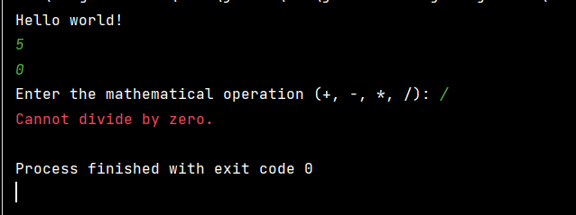

Task 4

import java.util.Scanner**;**public class Main {  
 public static void main(String[] args) {  
 System.*out*.println("Hello world!")**;** Scanner get = new Scanner(System.*in*)**;** System.*out*.println("Enter the Sentence")**;** String sentence**;** sentence=get.next()**;** try {  
 if (sentence==null){  
 throw new NullPointerException("String is enpty")**;** }  
 if (sentence.length() < **2**) {  
 System.*out*.println("Length is less than 2")**;** }  
 }catch (NullPointerException ne){  
 System.*out*.println("Error"+ne.getMessage())**;** }  
 }  
}

